CLAIM: Make a statement about how your star evolved or changed over time.
The Sun began life in a stellar nebula, became a G-yellow star with a luminosity of 3.828 x 10²⁶, a radius of 696,392 Km, a mass of 1.988 55x 10³⁰ and a temperature of 5,772 K. It will become a red giant and then a white dwarf and finally a black dwarf.
EVIDENCE: This is the scientific data selected that will support your claim. Your answers to the investigation questions your Google Sheet Data Table and the graphs will be used as evidence in this investigation.

Place all your graphs here. Under each graph describe what the graph is displaying. Also, describe any patterns that you are seeing in the graph. What are the relationships telling you?

For example: Luminosity vs. temperature graph: You need to describe each amount for your star, tell what stellar spectrum you are (OBFGKM), what color your star is and what phase of life (blue giant, main sequence, red giant, super red giant, or white dwarf) your star is in now.
For Radius vs. Mass: You must describe each amount for your star and then tell what that means. Are you a large star, an average star or a small star (radius) and then are you a large dense star, an average dense star or a small dense star?

The Sun Example of a graph summary
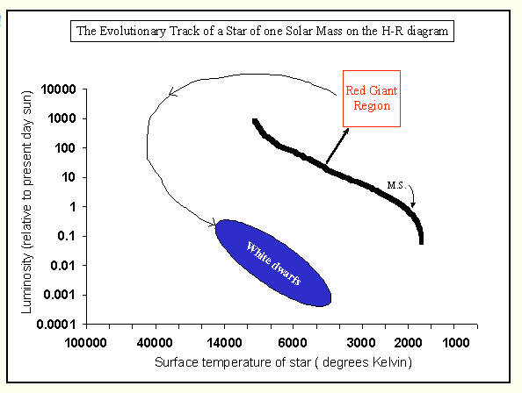

Summary: When the Sun has burned all of its hydrogen in its core, it will evolve off the main sequence and rise up the red giant branch.
Later, helium burning will commence, converting the helium in the core to carbon and oxygen. At this point, the Sun will be a red giant much cooler and bigger than the present day Sun. After all the helium is burned, the Sun will become a planetary nebula, blowing off its outer layers. The remnant carbon-oxygen core will become a white dwarf.

REASONING: This is the argument used to determine why your data supports the statement about how your star evolved or changed over time. Use your personal prior knowledge about star formation and evolution and any other scientific explanations or theories that can be used to describe why stars do what they do.

The Sun Example of Reasoning:

A cloud of gas and dust begins to contract under the force of gravity. In regions of star birth we find gaseous nebulae and molecular clouds. These sites of pre-birth are dark patches called globules. The protosun collapsed. As it did, its temperature rose to about 150,000 degrees and the sun appeared very red. Its radius was about 50 present solar radii. When the central temperature reaches 10 million degrees, nuclear burning of hydrogen into helium commences. The star settles into a stable existence on the Main Sequence, generating energy via hydrogen burning. This is the longest single stage in the evolutionary history of a star, typically lasting 90% of its lifetime. Thermonuclear fusion within the Sun is a stable process, controlled by its internal structure.
The hydrogen in the core is completed burned into helium nuclei. Initially, the temperature in the core is not hot enough to ignite helium burning. With no additional fuel in the core, fusion dies out. The core cannot support itself and contracts; as it shrinks, it heats up. The rising temperature in the core heats up a thin shell around the core until the temperature reaches the point where hydrogen burning ignites in this shell around the core. With the additional energy generation in the H-burning shell, the outer layers of the star expand but their temperature decreases as they get further away from the center of energy generation. This large but cool star is now a red giant, with a surface temperature of 3500 degrees and a radius of about 100 solar radii. The helium core contracts until its temperature reaches about 100 million degrees. At this point, helium burning ignites, as helium is converted into carbon (C) and oxygen (O). However, the core cannot expand as much as required to compensate for the increased energy generation caused by the helium burning. Because the expansion does not compensate, the temperature stays very high, and the helium burning proceeds furiously. With no safety valve, the helium fusion is uncontrolled and a large amount of energy is suddenly produced. This helium flash occurs within a few hours after helium fusion begins.
The core explodes, the core temperature falls and the core contracts again, thereby heating up. When the helium burns now, however, the reactions are more controlled because the explosion has lowered the density enough. Helium nuclei fuse to form carbon, oxygen, etc..
The star wanders around the red giant region, developing its distinct layers, eventually forming a carbon-oxygen core. When the helium in the core is entirely converted into C, O, etc., the core again contracts, and thus heats up again. In a star like the Sun, its temperature never reaches the 600 million degrees required for carbon burning. Instead, the outer layers of the star eventually become so cool that nuclei capture electrons to form neutral atoms (rather than nuclei and free electrons). When atoms are forming by capturing photons in this way, they cause photons to be emitted; these photons then are readily available for absorption by neighboring atoms and eventually this causes the outer layers of the star to heat up. When they heat up, the outer layers expand further and cool, forming more atoms, and releasing more photons, leading to more expansion. In other words, this process feeds itself.
The outer envelope of the star blows off into space, exposing the hot, compressed remnant core. This is a planetary nebula.
The core contacts but carbon burning never ignites in a one solar mass star. Contraction is halted when the electrons become degenerate, that is when they can no longer be compressed further. The core remnant as a surface temperature of a hot 10,000 degrees and is now a white dwarf .
With neither nuclear fusion nor further gravitational collapse possible, energy generation ceases. The star steadily radiates is energy, cools and eventually fades from view, becoming a black dwarf.

