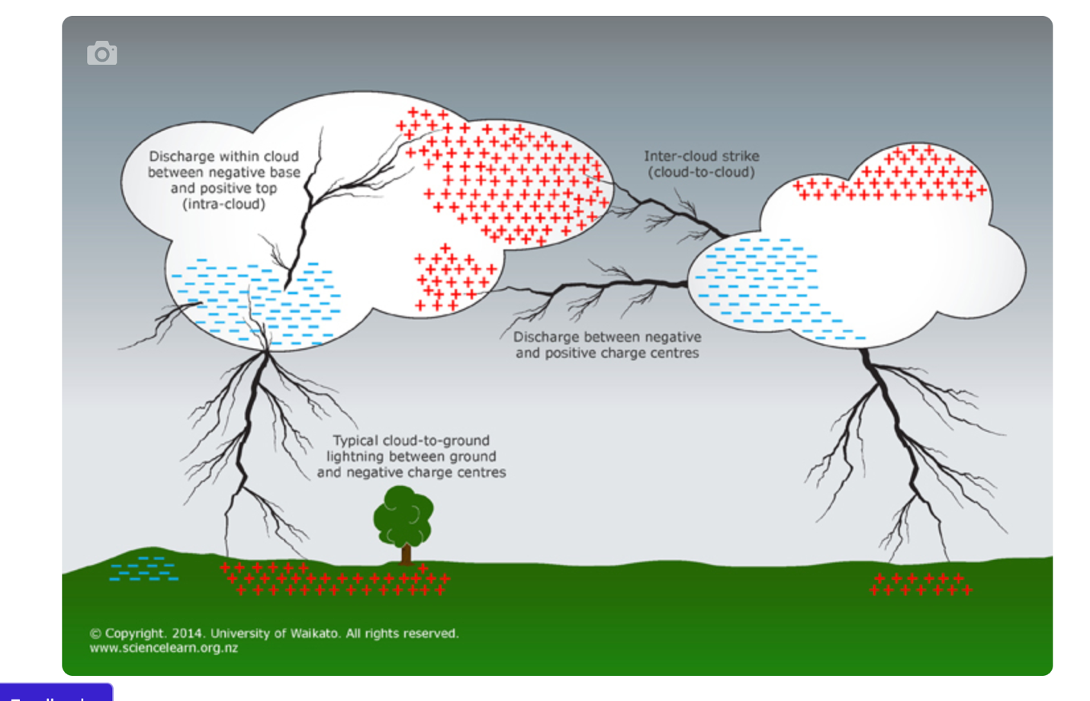

Lightning’s partner
Temperatures in the narrow lightning channel reach about 25,000°C. The surrounding air is rapidly heated, causing it to expand violently at a rate faster than the speed of sound, similar to a sonic boom. At about 10 m out from the channel, it becomes an ordinary sound wave called thunder.
Thunder is effectively exploding air, and when heard close to the lightning channel, it consists of one large bang. At about 1 km away, it is heard as a rumble with several loud claps. Distant thunder has a characteristic low-pitched rumbling sound. However, beyond 16 km, thunder is seldom heard.

Conditions needed for lightning to occur
It is the formation and separation of positive and negative electric charges within the atmosphere that creates the highly intensive electric field needed to support this natural spark discharge that is lightning.
The formation of electric charges in the atmosphere is due mainly to the ionisation of air molecules by cosmic rays. Cosmic rays are high-energy particles such as protons that originate from outside the solar system. On colliding with air molecules, they produce a shower of lighter particles, some of which are charged.

Lightning production
As the area of negative charge at the base of the thundercloud builds up, it induces a region of positive charge to develop on the ground below. As a result of this, a potential difference or voltage is created across the cloud-to-ground gap. Once the voltage reaches a certain strength, the air between the base of the cloud and the ground develops an electrical conductivity. At first a channel, known as a stepped leader, is formed. Although invisible to the naked eye, this allows electrons to move from the cloud to the ground.
It is called a stepped leader because it travels in 50 to 100 m sections, with a slight pause in between, to the ground. As it nears the ground, a positively charged streamer fires upwards from the ground to connect with it. Streamers are most often initiated from tall objects on the ground.
Once connected, electrons from the cloud can flow to the ground and positive charges can flow from the ground to the cloud. It is this flow of charge that is the visible lightning stroke.
After the first discharge, it is possible for another leader to form down the channel. Once again, a visible lightning stoke is seen. This can happen 3–4 times in quick succession. All of this happens in a time interval of about 200 milliseconds.
